Electric Supply Customer Management System
BCA 6th Semester CS-76 PROJECT
Tanmay Ghosh

Table of Contents
1. Introduction of the Project: 5
2. Objective of the Project: 7
Tools / Environment Used 8
3. Analysis of the Project: 11
3.1 Existing System 11
3.1.1 Documents maintained: 12
3.1.2 Problem faced in current process: 13
3.2 Proposed Electric Supply Customer Management System 14
3.2.1 ESCMS GUI: 14
3.2.1.1 User Interfaces: 15
3.2.1.2 User Interface Controller: 17
3.2.1.3 Engine Interactor: 17
3.2.2 ESCMS Engine 17
3.2.2.1 Engine Controller: 18
3.2.2.2 GUI Interactor: 18
3.2.2.3 Task Handler: 18
3.2.2.4 Data Entry Handler: 18
3.2.2.5 Customer Request Handler: 19
3.2.2.6 Access Controller: 19
3.2.2.7 Contract Request Handler: 19
3.2.2.8 Search Engine: 19
3.2.2.9 Legacy Format Converter: 19
3.2.2.10 Database Controller: 19
3.2.3 ESCMS Database 19
3.3 Hardware & Software Requirements for the application to run 20
3.3.1 Hardware Requirements 20
3.3.2 Hardware Requirements 20
3.4 E-R Diagram: 21
4 Tools/Platforms used (Hardware/Software): 25
Hardware: 25
Software: 25
5 Design Document: 25
6 Program code: 29
7 Testing: 30
Unit testing 30
Integration Testing 30
System Testing 31
8 Input and output screens: 32
9 Security measures: 32
10 limitations of the project: 32
11 Any Client/Industry: 32
12 Future Scope and Further enhancement of the project: 33
13 Bibliography: 34

Introduction of the Project:

Electric Supply Customer Management System (will be referred as ESCMS in this document) is a computerized solution for managing customer needs in Electric Supply offices. Currently the electric supply offices still use paper books and ledgers to track & manage customer applications, complaints. As a result of this it takes longer time and extra effort to serve customers with existing inefficient system. Electric Supply Customer Management System will enable electric supply offices to maintain computerized records and manage customer needs more efficiently with help of sophisticated customer management techniques and technologies.
Electric Supply Customer Management System will be used by Electric Supply Employees to enter various data about the Customers and their needs. The Employees will update the status of customer requests; track the progress of the work & transactions made in Electric Supply Customer Management System. It can generate reports and receipts required to serve customer request and queries. The below mentioned diagram shows the existing Customer Management System of Electric Supply offices which will be completely computerized with the help of this software.
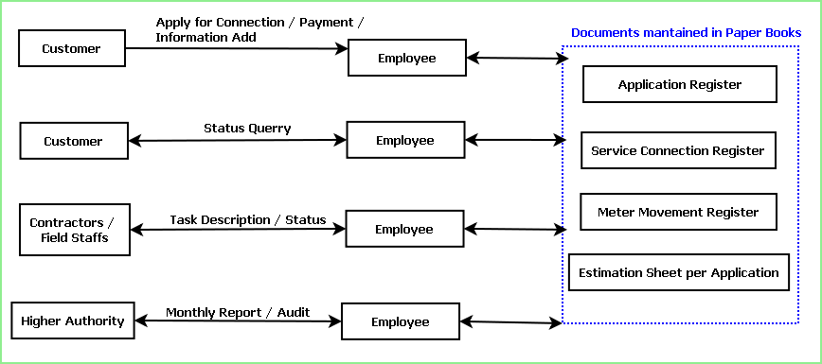

The main advantages of Electric Supply Customer Management System over existing traditional paper book and ledger system are given below:
- It is faster as the computer is doing the searching and fetching of data.
- It is more efficient as it reduces the need of more employees.
- It is more accurate.
- It can generate paper report and main ledgers to help transition from older system.
- It can store the data in a centralized server so that data will available to use any where. So the auditing of the data can be done without physically being present to the site.

Objective of the Project:
The objectives of the project are given below:
- This software will save the time of the customer and the electric supply employees.
- This software will manage the customer data more efficiently.
- It allows searching, adding, modifying various information more organized way.
- It helps to streamline the transactions
- It helped me to learn a lot about software development and its processes.
- IT helped me to learn new cutting edge technologies like .NET, WPF, MSSQL

Tools / Environment Used

IDE Used (Visual Studio 2010):

Microsoft Visual Studio is a powerful IDE that ensures quality code throughout the entire application lifecycle, from design to deployment. Whether we are developing applications for SharePoint, the web, Windows, Windows Phone, and beyond, Visual Studio is the ultimate all-in-one solution. Visual Studio includes a code editor supporting IntelliSense as well as code refactoring. The integrated debugger works both as a source-level debugger and a machine-level debugger. Other built-in tools include a forms designer for building GUI applications, web designer, class designer, and database schema designer. It accepts plug-ins that enhance the functionality at almost every level—including adding support for source-control systems (like Subversion and Visual SourceSafe) and adding new toolsets like editors and visual designers for domain-specific languages or toolsets for other aspects of the software development lifecycle (like the Team Foundation Server client: Team Explorer).

Front End: WPF (Windows Presentation Framework)
Windows Presentation Foundation (WPF) provides developers with a unified programming model for building rich Windows smart client user experiences that incorporate UI, media, and documents. Windows Presentation Foundation (WPF) is a next-generation presentation system for building Windows client applications with visually stunning user experiences. With WPF, you can create a wide range of both standalone and browser-hosted applications. The core of WPF is a resolution-independent and vector-based rendering engine that is built to take advantage of modern graphics hardware. WPF extends the core with a comprehensive set of application-development features that include Extensible Application Markup Language (XAML), controls, data binding, layout, 2-D and 3-D graphics, animation, styles, templates, documents, media, text, and typography. WPF is included in the Microsoft .NET Framework, so you can build applications that incorporate other elements of the .NET Framework class library.

Programming Framework (.NET 4):

The .NET 4 Framework is Microsoft's platform for building applications that have visually stunning user experiences, seamless and secure communication, and the ability to model a range of business processes. The .Net Framework consists of:
- Common Language Runtime – provides an abstraction layer over the operating system
- Base Class Libraries – pre-built code for common low-level programming tasks
- Development frameworks and technologies – reusable, customizable solutions for larger programming tasks.
The framework's Base Class Library provides user interface, data access, database connectivity, cryptography, web application development, numeric algorithms, and network communications. The class library is used by programmers, who combine it with their own code to produce applications.

Programming Language (C#):
C# is a type-safe, object-oriented language that is simple yet powerful, allowing programmers to build a breadth of applications. C# is a multi-paradigm programming language encompassing imperative, declarative, functional, generic, object-oriented(class-based), and component-oriented programming disciplines. It was developed by Microsoft within the .NET initiative and later approved as a standard by Ecma (ECMA-334) and ISO (ISO/IEC 23270). C# is one of the programming languages designed for the Common Language Infrastructure.
C# is intended to be a simple, modern, general-purpose, object-oriented programming language.

Database Microsoft SQL Server 2008

Microsoft SQL Server 2008 is a complete set of enterprise-ready technologies and tools that help people derive the most value from information at the lowest total-cost-of-ownership. Enjoy high levels of performance, availability, and security; employ more productive management and development tools; and deliver pervasive insight with self-service business intelligence (BI). Its main Highlights are
- Complete information platform for applications of all sizes.
- Managed, familiar self-service BI tools.
- Support for large-scale data centers and data warehouses.
- Opportunities to build and extend applications in the cloud.
- Integration with the Microsoft Application Platform.

Extensible Markup Language (XML)
Extensible Markup Language (XML) is a simple, very flexible text format derived from SGML (ISO 8879). Originally designed to meet the challenges of large-scale electronic publishing, XML is also playing an increasingly important role in the exchange of a wide variety of data on the Web and elsewhere.
Extensible Markup Language (XML) is a set of rules for encoding documents in machine-readable form. It is defined in the XML 1.0 Specification produced by the W3C, and several other related specifications, all gratis open standards.
XML's design goals emphasize simplicity, generality, and usability over the Internet.[6] It is a textual data format with strong support via Unicode for the languages of the world. Although the design of XML focuses on documents, it is widely used for the representation of arbitrary data structures, for example in web services.
Many application programming interfaces (APIs) have been developed that software developers use to process XML data, and several schema systems exist to aid in the definition of XML-based languages.
As of 2009, hundreds of XML-based languages have been developed,[7] including RSS, Atom, SOAP, and XHTML. XML-based formats have become the default for most office-productivity tools, including Microsoft Office (Office Open XML), OpenOffice.org (OpenDocument), and Apple's iWork.
System.Xml is the core XML manipulation technology for .NET languages.

Windows Communication FRAMEWORK (WCF)
Windows Communication Foundation (WCF) is a framework for building service-oriented applications. Using WCF, you can send data as asynchronous messages from one service endpoint to another. A service endpoint can be part of a continuously available service hosted by IIS, or it can be a service hosted in an application. An endpoint can be a client of a service that requests data from a service endpoint. The messages can be as simple as a single character or word sent as XML, or as complex as a stream of binary data. A few sample scenarios include:
- A secure service to process business transactions.
- A service that supplies current data to others, such as a traffic report or other monitoring service.
- A chat service that allows two people to communicate or exchange data in real time.
- A dashboard application that polls one or more services for data and presents it in a logical presentation.
- Exposing a workflow implemented using Windows Workflow Foundation as a WCF service.
- A Silverlight application to poll a service for the latest data feeds.
While creating such applications was possible prior to the existence of WCF, WCF makes the development of endpoints easier than ever. In summary, WCF is designed to offer a manageable approach to creating Web services and Web service clients.

Dia for Diagram Drawing & Modeling
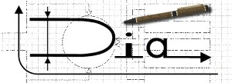
Dia is free and open source general-purpose diagramming software, developed as part of the GNOME project's office suite and was originally created by Alexander Larsson. Dia uses a controlled single document interface (CSDI) similar to GIMP and Sodipodi.
Dia has a modular design with several shape packages available for different needs: flowchart, network diagrams, circuit diagrams, and more. It does not restrict symbols and connectors from various categories from being placed together.
Dia is a gtk+ based diagram creation program released under the GPL license.
Dia is inspired by the commercial Windows program 'Visio', though more geared towards informal diagrams for casual use. It can be used to draw many different kinds of diagrams. It currently has special objects to help draw entity relationship diagrams, UML diagrams, flowcharts, network diagrams, and many other diagrams. It is also possible to add support for new shapes by writing simple XML files, using a subset of SVG to draw the shape.

It can load and save diagrams to a custom XML format (gzipped by default, to save space), can export diagrams to a number of formats, including EPS, SVG, XFIG, WMF and PNG, and can print diagrams (including ones that span multiple pages).

Google Spreadsheet Interface:

With Google Spreadsheets, we can easily create, share, and edit spreadsheets online. Here are a few specific things we can do:
- Import and export these file types: .xls, .csv, .txt and .ods. We can also export data to a PDF or an HTML file.
- Format cells and edit formulas so we can calculate results and make data look the way we want it.
- Chat in real time with others who are editing our spreadsheet.
- Embed a spreadsheet, or a section of a spreadsheet, in our blog or website.

Analysis of the Project:

Existing System
The existing system is traditional paper books and ledger system where several registers are maintained to store user request and to track other details about the request. The flow diagram of how a customer request executed now is shown below:
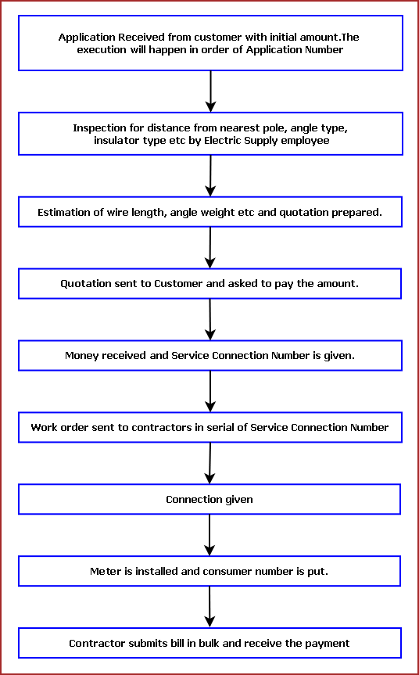

Documents maintained:
- Application Register: Application Number, Name, Address with Contact Number, Load, Initial Deposit Amount, Application Received Date, Quotation Amount, Quotation Sent Date, Amount Received On, Service Connection Number

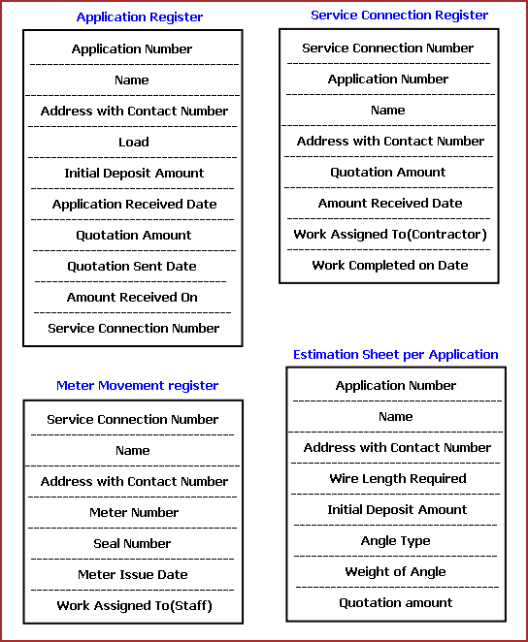
- Service Connection Register: Service Connection Number, Application Number, Name, Address with Contact Number, Quotation Amount, Amount Received Date, Work Assigned To (Contractor), Work Completed on Date
- Meter Movement Register: Service Connection Number, Name Address with Contact Number, Meter Number, Seal Number, Meter Issue Date, Work Assigned To (Staff), Date of Connection
- Estimation Sheet per Application: contains input Application Number, name, Address with Contact Number, Wire Length Required, Angle Type and calculates Weight of Angle, and Quotation amount

Problem faced in current process:
- Data needs to be repeated across registers. It takes more time to entry the data. And while searching the employees need to look up the data in several places to get the specific data required.
- The application register is maintained in serial of Application Number, where the service connection and meter Movement register is maintained in serial of Service Connection Number. All the processes after submission of quotation amount are in order of service connection number. In current process employees need to find the application details of a service connection in application register which is a cumbersome job.
- Service Connection Register includes only quotation amount, but for service connection order Electric Supply need to provide the contractor & the store the estimation details like, length of wire, angle type etc. and the orders are generally bulk order. So, Electric Supply need to prepare all these estimation details in a tabular format for a number of service connection numbers and give it to the contractor and store.
- When contractors submits the bills Electric Supply need to check if the work is completed and whether he has already taken the payment . So Electric Supply needs to refer to the details of a contractor like assigned tasks, completion date, payment data, bill details for contractor, summary of task done by a contractor which requires collecting the data from several registers and documents.
From the above mentioned issues we can understand that existing system is more time consuming, not efficient and not utilizing the employees working time.

Proposed Electric Supply Customer Management System
Electric Supply Customer Management System will upgrade the existing system, so it needs to have good support for existing system as well. It will collect the data from customers & employees and populate records which will match existing paper book registers. So that employees can take print out and maintain similar records. Electric Supply Customer Management System consists of three main modules:

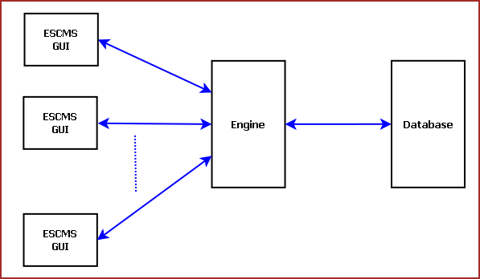
Figure: Overview of ESCMS

ESCMS GUI:
ESCMS GUI will help users to log data, query information and control the flow of operations. Multiple instances of GUI can be opened in several machines which will interact with a Centralized engine and database. There are three main module of GUI: Such as:
- User Interfaces
- User Interface Controller
- Engine Interactor

User Interfaces:
User interfaces help users to log data and view displayed results. The main modules are described below:
- User Registration:
This interface will allow registering the Users of Electric Supply Office. The users can be of three types such as Employee, Customer & Contractor. Only employees will be allowed to use the application directly. Customers & Contractor will use this application through an Electric Supply employee. First every user needs to be registered and feed some necessary information about them. Then the system will register the User and generate a unique id for them. Any further communication will be tracked through that id.
- Customer Request Interface:
This interface will log customer request and gather required information about the request and trigger an action.
- Service Application Interface:
This interface will log user’s application for a new service connection where all the user details will be furnished.
- Estimate Interface:
The employees will use this interface for logging estimate information about a service connection.
- Information Browser:
This interface will allow employees to browse any information about Electric Supply office users, User request, Tasks, Contract requests.
- Employee Login:
Employees need to login to this software using their Id and password. There will two types of permission: Administrative permission & User Permission. Managers will have administrative permissions to generate login id/ password for normal employees, assign tasks to employees and approve ordering from contractors.
- Billing Interface:
Billing interface will help logging customer payment and contractor payments information.
- Task Assign Interface:
The administrator/ managers will assign tasks to employees using this interface.

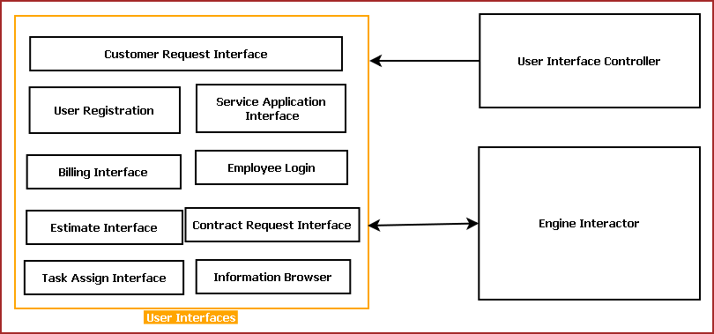. Figure: Different modules of ESCMS GUI
- Contract Request Interface:
This interface will be used to order materials from Contractors and track their payments and deliveries

User Interface Controller:
User Interface Controller manages the User Interfaces, passes the user request to Engine Interactor and displays the reply from Engine Interactor.

Engine Interactor:
Engine Interactor passes the user information to Engine and polls for engine replies. It acts as a bridge between the multiple GUIs and centralized Engine.

ESCMS Engine
ESCMS Engine will control overall application flow and interaction between GUI & database. ESCMS will have a centralized engine where multiple GUI will tune into.

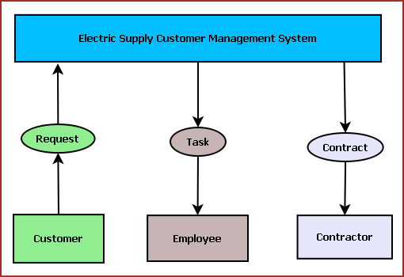
Figure: ESCMS interaction with Users
ESCMS has three kind of users and three different form of interaction mechanism adopted for each of them. Every customer interaction is encapsulated as Request and ESCMS forms task for employee and contracts for contractors.
ESCMS Engine is divided into ten modules which are described below:

Engine Controller:
It controls all the engine components. It interprets the requests from GUI Interactor and assigns to the appropriate module. Engine Controller retrieves the query result from Database Controller and bypass to specific User interface via GUI Interactor.

GUI Interactor:
It controls communication with GUI. It exposes Engine events and APIs for GUI use.

Task Handler:
This module generates specific tasks for employees. It schedules task, associates priority depending severity of user need. Backend controller processes Customer requests and Contractor request and prepares task for Employees.

Data Entry Handler:
This module parses user logged data and passes to Database controller for saving it. Data entry handler validates user input and triggers warning.
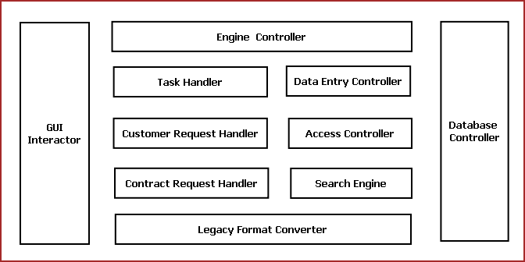
Figure: Different modules of ESCMS engine

Customer Request Handler:
This module controls and serves Customer Requests. It distinguishes the user request and triggers appropriate actions. Customer can request for new service connection, status update and payment. Customer request handler interacts with database controller to serve user requests.

Access Controller:
This module takes care of access rights of different kinds of users. This module registers new users and validates user login.

Contract Request Handler:
This module generates contract requests for contractors depending on customer needs and electric supply employee inputs. It also tracks contractor contract details, payments history.

Search Engine:
This module will prepare search indexes for different kinds of user data. Whenever information-browser of GUI request for some data it will query from database controller depending on optimized search index and send it back to the User.

Legacy Format Converter:
Legacy format converter module will help to achieve compatibility for existing system. It is not possible to switch to a new system all of a sudden. Legacy format converter will recreate existing system like records. Employees can take print out and maintain similar kind of registers.

Database Controller:
Database controller will feed data to database and query the requested data from the centralized database. It will also archive old data to use database efficiently.

ESCMS Database
ESCMS database is the most important component of this software. The efficiency of the software depends on the optimized database design. We will design a optimized RDBMS using MySQL. The entities of the data are given below:
- Customer
- Service Request
- Meter Request
- Electric Supply Office
- Employee
- Contractor
- Contract Request

Hardware & Software Requirements for the application to run

Hardware Requirements
- Computer that has a 1.6GHz or faster processor
- 1 GB (32 Bit) or 2 GB (64 Bit) RAM
- 10 MB of available hard disk space
- DVD-ROM Drive / USB Port

Hardware Requirements
- Windows XP (x86) with Service Pack 3 / Windows Vista (x86 & x64) with Service Pack 2 / Windows 7 (x86 & x64)
- Microsoft .NET 4.0

E-R Diagram:
We will design a RDBMS for File Management System. The entities and their attributes are listed below. Attributes in Bold letter is the unique key.
Entities | Attributes
Customer | Customer Id, Name, Address , Contact Number, Payments
Customer Request | Request Id, type, Description
Service Application | Application Number, Service Type , Quotation Amount, Payment
Estimate | Application Number, items
Service Connection | Service Connection Number, Meter Number, Seal Number, Meter Issue Date
Electric Supply Office | Branch Id , Branch Name, Branch Address, Total Customer
Employee | Employee Id, Name, Admin Right
Contractor | Contractor Id, Name, payment, delivery
Contract Request | Contract Request Id, Type, Description
Task | Task Id, Task Type, Description

Relationship between Entities:
- Electric Supply office has Customers→ 1 : N
- Electric Supply office has Contractors→ 1 : N
- Electric Supply office has Employees→ 1 : N
- Customer does Requests → 1 : N
- Electric Supply serves Requests → 1 : N
- User uses Service Connection → 1 : N
- Employees provides Estimates → M : N
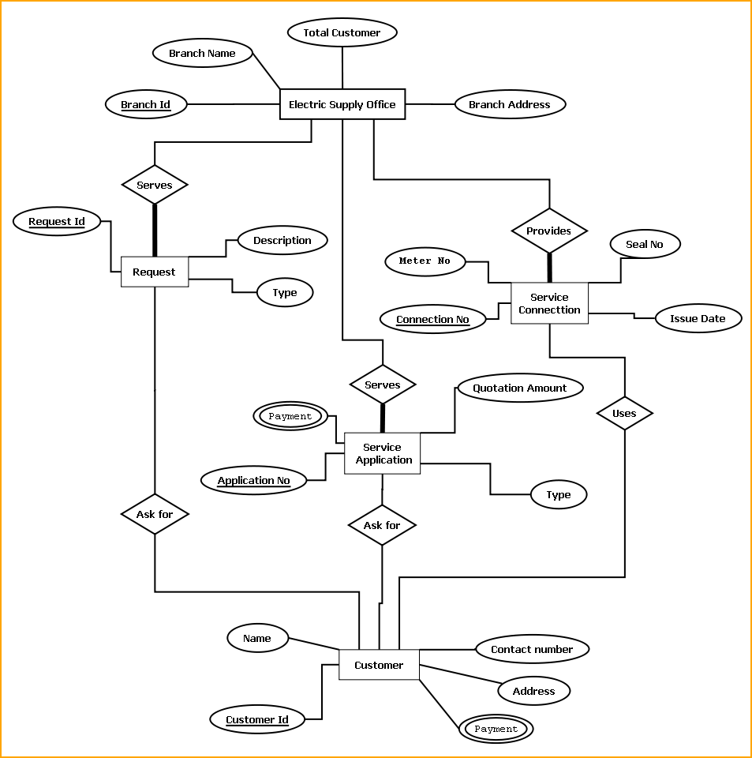
E-R Diagram of Electric Supply Customer Management System
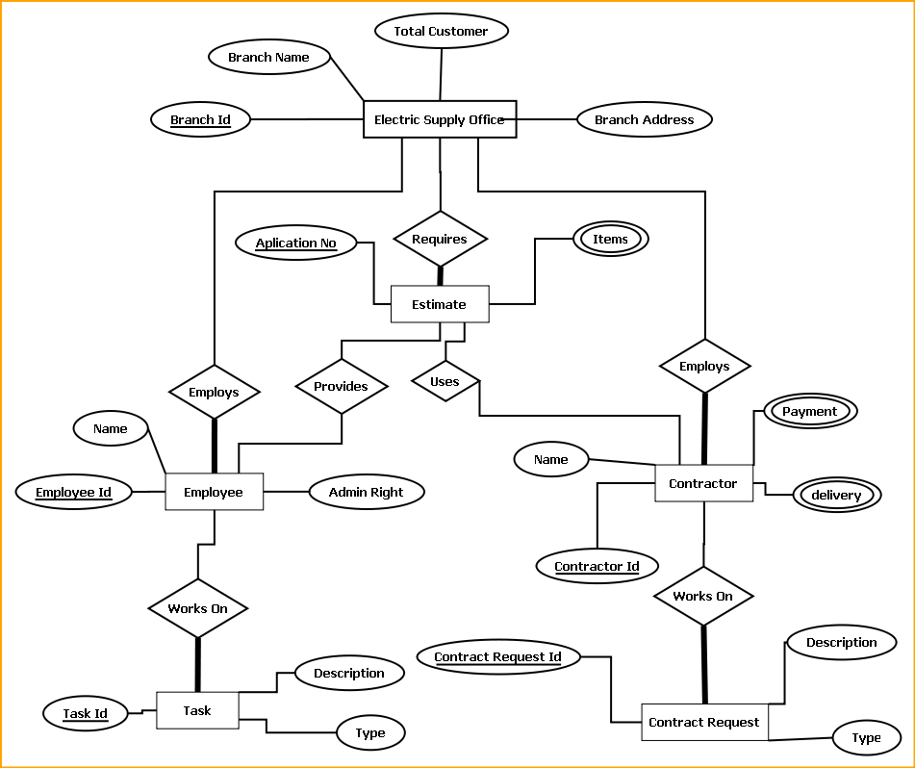
E-R Diagram of Electric Supply Customer Management System

Design Document:
The user interface is developed using WPF.
Menu bar contains the important features which can be accessed by shortcuts too. It is implemented using Menu control.
System.Windows.Controls.Menu
Namespace: System.Windows.Controls
Assembly: PresentationFramework (in PresentationFramework.dll)
Represents a Windows menu control that enables you to hierarchically organize elements associated with commands and event handlers.

Toolbar lists down the mostly used features. It is implemented using ToolBar control.
System.Windows.Controls.ToolBar
Namespace: System.Windows.Controls
Assembly: PresentationFramework (in PresentationFramework.dll)
Provides a container for a group of commands or controls.

Left navigation bar displays the tutorials available locally and online. This navigation bar is hide- able. It is implemented using the Expander control.
System.Windows.Controls.Expander
Namespace: System.Windows.Controls
Assembly: PresentationFramework (in PresentationFramework.dll)
Represents the control that displays a header that has a collapsible window that displays content.

The local contents are displayed in a TreeView control. And every contents are displayed in in a TreeViewItem.
System.Windows.Controls.TreeView
Namespace: System.Windows.Controls
Assembly: PresentationFramework (in PresentationFramework.dll)
Represents a control that displays hierarchical data in a tree structure that has items that can expand and collapse.

Online contents are displayed in a WebBrowser control. Users can select the content and purchase it from there.
System.Windows.Controls.WebBrowser
Namespace: System.Windows.Controls
Assembly: PresentationFramework (in PresentationFramework.dll)
Hosts and navigates between HTML documents. Enables interoperability between WPF managed code and HTML script.

Textpane displays the Texts. This is implemented using a TextBlock control.
System.Windows.Controls.TextBlock
Namespace: System.Windows.Controls
Assembly: PresentationFramework (in PresentationFramework.dll)
Provides a lightweight control for displaying small amounts of flow content.

Video and audio playing is implemented using MediaElement control.
System.Windows.Controls.MediaElement
Namespace: System.Windows.Controls
Assembly: PresentationFramework (in PresentationFramework.dll)
Represents a control that contains audio and/or video.

Images are displayed using Image control.
System.Windows.Controls.Image
Namespace: System.Windows.Controls
Assembly: PresentationFramework (in PresentationFramework.dll)
Represents a control that displays an image.

Drawing pane is implemented using InkCanvas control.
System.Windows.Controls.InkCanvas
Namespace: System.Windows.Controls
Assembly: PresentationFramework (in PresentationFramework.dll)
Defines an area that receives and displays ink strokes.

Statusbar displays the information about the application and the tutorial currently running. Its implemented using StatusBar Class.
System.Windows.Controls.Primitives.StatusBar
Namespace: System.Windows.Controls.Primitives
Assembly: PresentationFramework (in PresentationFramework.dll)
Represents a control that displays items and information in a horizontal bar in an application window.

Engine Design:
Reading & Writing XML:
In this application the tutorials are saved as XML file. The application will process the XML and play the tutorial. So we have implemented XML reader and writer logic. XML operations are done using .NET XML parser. Every XML element is represented as a XElement control.
System.Xml.Linq.XElement
Namespace: System.Xml.Linq
Assembly: System.Xml.Linq (in System.Xml.Linq.dll)
Represents an XML element.

Installer:
This software is packaged using Visual studio Installer utility. It provides a MSI file to be installed on end user side.
This installer will include all the required DLL to run this software

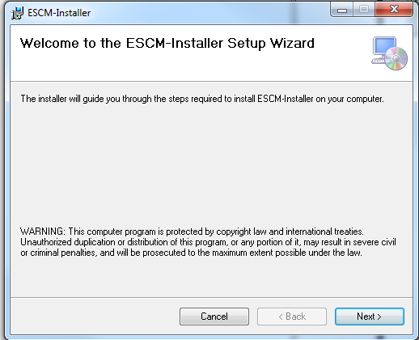
The users can browse the installation folder for this software and install the software in the desired path.

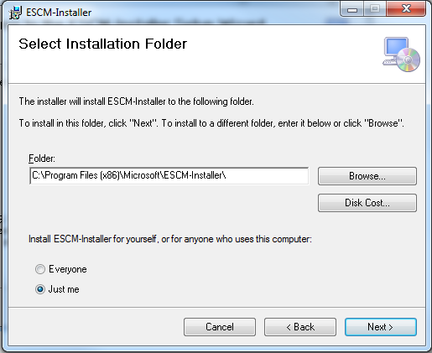

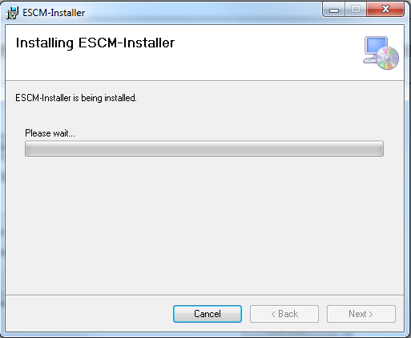

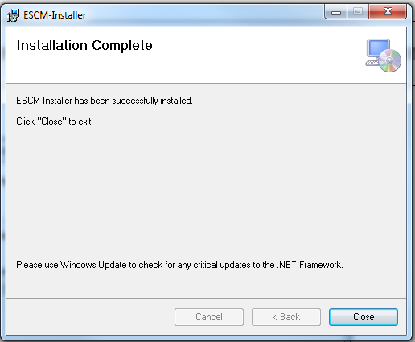

Program code:

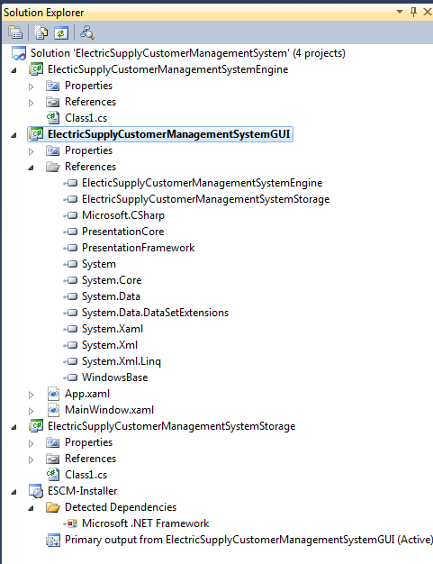

GUI CODE
MainWindow.xaml
<Window x:Class="ElectricSupplyCustomerManagementSystemGUI.MainWindow"
xmlns="http://schemas.microsoft.com/winfx/2006/xaml/presentation"
xmlns:x="http://schemas.microsoft.com/winfx/2006/xaml"
Title="ElectricSupplyCustomerManagementSystem" Height="350" Width="525">

<DockPanel LastChildFill="True">
<Menu DockPanel.Dock="Top">
<MenuItem Header="File">
<MenuItem Header="Employee Login"></MenuItem>
<MenuItem Header="New Connection"></MenuItem>
<MenuItem Header="Query"></MenuItem>
<MenuItem Header="Payment"></MenuItem>
<MenuItem Header="Inspection Order"></MenuItem>
<MenuItem Header="Estimate and Quotation"></MenuItem>
<MenuItem Header="Work Order"></MenuItem>
<MenuItem Header="Contractor Bill"></MenuItem>
<MenuItem Header="Close" Name="closeBtn" Click="closeBtn_Click"></MenuItem>
</MenuItem>
<MenuItem Header="View">

</MenuItem>

<MenuItem Header="Tools"></MenuItem>
<MenuItem Header="Help"></MenuItem>

</Menu>
<ToolBar DockPanel.Dock="Top">
<Label>Employee: </Label>
<Label>Not Logged In.</Label>
<Separator></Separator>
<Label>Access:</Label>
<Label>User</Label>
<Separator></Separator>
<Button>Log In</Button>
</ToolBar>
<StatusBar DockPanel.Dock="Bottom">
<Label>Time:</Label>
<ProgressBar Width="100" Height="30"></ProgressBar>
</StatusBar>
<UniformGrid Columns="3" DockPanel.Dock="Bottom">
<Button Content="Employee Login"></Button>
<Button Content="New Connection"></Button>
<Button Content="Query"></Button>
<Button Content="Payment"></Button>
<Button Content="Inspection Order"></Button>
<Button Content="Estimate and Quotation"></Button>
<Button Content="Work Order"></Button>
<Button Content="Contractor Bill"></Button>
<Button>Search</Button>
<Button>Connections Browser</Button>
<Button>Employee Browser</Button>
<Button>Contractor Browser</Button>
</UniformGrid>
</DockPanel>
</Window>

Upload to Web
/* Copyright (c) 2007 Google Inc.
*
* Licensed under the Apache License, Version 2.0 (the "License");
* you may not use this file except in compliance with the License.
* You may obtain a copy of the License at
*
* http://www.apache.org/licenses/LICENSE-2.0
*
* Unless required by applicable law or agreed to in writing, software
* distributed under the License is distributed on an "AS IS" BASIS,
* WITHOUT WARRANTIES OR CONDITIONS OF ANY KIND, either express or implied.
* See the License for the specific language governing permissions and
* limitations under the License.
*/

using System;
using System.Collections.Generic;
using System.ComponentModel;
using System.Data;
using System.Drawing;
using System.Diagnostics;
using System.Text;
using System.Windows.Forms;
using Google.GData.Client;
using Google.GData.Documents;

namespace DocListUploader
{
public partial class OptionsForm : Form
{
private bool lastToolTipWasUpload = false;
public bool loggedIn = false;
private string file = "c:\\testfile.txt";
private DocumentsService service;
private DocumentEntry lastUploadEntry = null;
/// <summary>
/// Constructor for the OptionsForm.
/// </summary>
/// <param name="mainForm">The parent form that created this one.</param>
public OptionsForm()
{
InitializeComponent();
}

private void LoginButton_Click(object sender, EventArgs e)
{
if (Username.Text == "")
{
MessageBox.Show("Please specify a username", "No user name", MessageBoxButtons.OK, MessageBoxIcon.Error);
return;
}
if (Password.Text == "")
{
MessageBox.Show("Please specify a password", "No password", MessageBoxButtons.OK, MessageBoxIcon.Error);
return;
}

try
{
LoginButton.Text = "Logging In";

LoginButton.Enabled = false;
LogoutButton.Enabled = true;

Username.Enabled = false;
Password.Enabled = false;
Login(Username.Text, Password.Text);
LoginButton.Text = "Logged In";

}
catch (Exception ex)
{
LoginButton.Enabled = true;
LogoutButton.Enabled = false;
Username.Enabled = true;
Password.Enabled = true;

LoginButton.Text = "Login";

MessageBox.Show("Error logging into Google Docs: " + ex.Message, "Login Error", MessageBoxButtons.OK, MessageBoxIcon.Error);
}
}

private void Username_KeyPress(object sender, KeyPressEventArgs e)
{
//If the user hits enter, skip to the next field.
if (e.KeyChar == (char) 13)
{
Password.Focus();
}
}

/// <summary>
/// Authenticates to Google servers
/// </summary>
/// <param name="username">The user's username (e-mail)</param>
/// <param name="password">The user's password</param>
/// <exception cref="AuthenticationException">Thrown on invalid credentials.</exception>
public void Login(string username, string password)
{
if (loggedIn)
{
throw new ApplicationException("Already logged in.");
}
try
{
service = new DocumentsService("DocListUploader");
((GDataRequestFactory)service.RequestFactory).KeepAlive = false;
service.setUserCredentials(username, password);
//force the service to authenticate
DocumentsListQuery query = new DocumentsListQuery();
query.NumberToRetrieve = 1;
service.Query(query);
loggedIn = true;
}
catch (AuthenticationException e)
{
loggedIn = false;
service = null;
throw e;
}
}

/// <summary>
/// Logs the user out of Google Docs.
/// </summary>
public void Logout()
{
loggedIn = false;
service = null;
}

/// <summary>
/// Some error handling around the file upload method. Used for handling files from the context menu.
/// </summary>
/// <param name="file">The file to upload.</param>
public void HandleUpload(string file)
{
if (!loggedIn)
{
MessageBox.Show("Please log in before uploading documents", "Upload Error", MessageBoxButtons.OK, MessageBoxIcon.Error);
return;
}
try
{
lastToolTipWasUpload = false;
UploadFile(file);
lastToolTipWasUpload = true;

}
catch (ArgumentException)
{
//DocListNotifyIcon.ShowBalloonTip(BALLOON_TIMER, "Upload Error", "Error: unable to upload the file: '" + file + "'. It is not one of the valid types.", ToolTipIcon.Error);
lastToolTipWasUpload = false;
}
catch (Exception ex)
{
//DocListNotifyIcon.ShowBalloonTip(BALLOON_TIMER, "Upload Error", "Error: unable to upload the file: '" + file + "'. " + ex.Message, ToolTipIcon.Error);
lastToolTipWasUpload = false;
}
}

/// <summary>
/// Uploads the file to Google Docs
/// </summary>
/// <param name="fileName">The file with path to upload</param>
/// <exception cref="ApplicationException">Thrown when user isn't logged in.</exception>
public void UploadFile(string fileName)
{
if (!loggedIn)
{
throw new ApplicationException("Need to be logged in to upload documents.");
}
else
{
lastUploadEntry = service.UploadDocument(fileName, null);
}
}

private void Password_KeyPress(object sender, KeyPressEventArgs e)
{
//If the user hits enter, try to log in.
if (e.KeyChar == (char) 13)
{
LoginButton_Click(null, null);
}
}

private void button1_Click(object sender, EventArgs e)
{
if (!mainForm.loggedIn)
{
MessageBox.Show("Please log in before uploading documents", "Upload Error", MessageBoxButtons.OK, MessageBoxIcon.Error);
return;
}

try
{
statusLabel.Text = "Uploading " + file;
this.Refresh();
mainForm.UploadFile(file);
statusLabel.Text = "Successfully uploaded " + file;

}
catch (ArgumentException)
{
DialogResult result = MessageBox.Show("Error, unable to upload the file: '" + file + "'. It is not one of the valid types.", "Upload Error", MessageBoxButtons.OKCancel, MessageBoxIcon.Error);
statusLabel.Text = "Problems uploading";
if (result == DialogResult.Cancel)
{
return;
}
}
catch (Exception ex)
{
DialogResult result = MessageBox.Show("Error, unable to upload the file: '" + file + "'. " + ex.Message, "Upload Error", MessageBoxButtons.OKCancel, MessageBoxIcon.Error);
statusLabel.Text = "Problems uploading";
if (result == DialogResult.Cancel)
{
return;
}
}
}

private void LogoutButton_Click(object sender, EventArgs e)
{
mainForm.Logout();
LoginButton.Enabled = true;
LogoutButton.Enabled = false;
Username.Enabled = true;
Password.Enabled = true;
LoginButton.Text = "Login";
}
}
}
/* Copyright (c) 2007 Google Inc.
*
* Licensed under the Apache License, Version 2.0 (the "License");
* you may not use this file except in compliance with the License.
* You may obtain a copy of the License at
*
* http://www.apache.org/licenses/LICENSE-2.0
*
* Unless required by applicable law or agreed to in writing, software
* distributed under the License is distributed on an "AS IS" BASIS,
* WITHOUT WARRANTIES OR CONDITIONS OF ANY KIND, either express or implied.
* See the License for the specific language governing permissions and
* limitations under the License.
*/

using System;
using System.Collections.Generic;
using System.ComponentModel;
using System.Data;
using System.Drawing;
using System.Diagnostics;
using System.IO;
using System.Text;
using System.Windows.Forms;
using System.Threading;
using System.Runtime.Remoting;
using System.Runtime.Remoting.Channels;
using System.Runtime.Remoting.Channels.Ipc;
using Microsoft.Win32;
using Google.GData.Documents;
using Google.GData.Client;

namespace DocListUploader
{
/// <summary>
/// The main form of the uploader, controls most of the service interaction.
/// It is not actually displayed to the user.
/// </summary>
public partial class HiddenForm : Form
{
//A child form for the user to interact with.
private OptionsForm optionsForm;
//Keeps track of our logged in state.

//A connection with the DocList API.

//The name of the shell context menu option.
private const string KEY_NAME = "Send to Google Docs";
//Keeps track of if we've minimized the OptionsForm before.
private bool firstMinimize = true;
//The timer in milliseconds to display balloon tips.
private const int BALLOON_TIMER = 10000;
//The most recently uploaded document.

//Keeps track of if the last balloon tip was an upload complete message.

/// <summary>
/// Constructor for the form.
/// </summary>
public HiddenForm()
{
InitializeComponent();
optionsForm = new OptionsForm(this);
ListenForSuccessor();
}

/// <summary>
/// The main entry point for the application.
/// </summary>
[STAThread]
static void Main(string[] args)
{
bool firstInstance;
Mutex mutex = new Mutex(true, "Local\\DocListUploader", out firstInstance);
if (!firstInstance)
{
//If we have an argument, we were most likely called by
//the shell context menu
if (args.Length == 1)
{
NotifyPredecessor(args[0]);
}
return;
}
Application.EnableVisualStyles();
Application.SetCompatibleTextRenderingDefault(false);
Application.Run(new HiddenForm());
}

/// <summary>
/// This is run by the first instance of the program in order
/// to accept information from later instances using the
/// .NET Framework's IPC mechanism.
/// </summary>
public void ListenForSuccessor()
{
IpcServerChannel serverChannel = new IpcServerChannel("DocListUploader");
ChannelServices.RegisterChannel(serverChannel, false);

RemoteMessage remoteMessage = new RemoteMessage(this);
RemotingServices.Marshal(remoteMessage,"FirstInstance");

}

/// <summary>
/// This is used by later instances of the program when
/// executed from the shell's context menu to pass along
/// the path of a file that will be uploaded. This message
/// is passed using the .NET Framework's IPC mechanism.
/// </summary>
/// <param name="file">The file to be uploaded</param>
public static void NotifyPredecessor(string file)
{
IpcClientChannel clientChannel = new IpcClientChannel();
ChannelServices.RegisterChannel(clientChannel, false);

RemoteMessage message = (RemoteMessage) Activator.GetObject(typeof(RemoteMessage), "ipc://DocListUploader/FirstInstance");

if (!message.Equals(null))
{
message.SendMessage(file);
}
}

/// <summary>
/// Retrieves a list of documents from the server.
/// </summary>
/// <returns>The list of documents as a DocumentsFeed.</returns>
public DocumentsFeed GetDocs()
{
DocumentsListQuery query = new DocumentsListQuery();
DocumentsFeed feed = service.Query(query);
return feed;
}

}
}

Algorithm for Database Connection:
Step1: Create connection
try
{
string dbConnectionString = "Data Source=9.126.164.183;Initial Catalog=
BTT_MESSAGE_INTEGRATION_Dave;User ID=wtrkplusdev;Password=wtrkplus0123;";
SqlConnection connection = new SqlConnection(dbConnectionString);
connection.Open();
} catch (SqlException sqlException)
{
// message
}
step2: Create a stored procedure command
SqlCommand sqlCommand = new SqlCommand(commandName, connection);
sqlCommand.CommandType = System.Data.CommandType.StoredProcedure;
sqlCommand.Transaction = transaction;
Step3: provide necessary input and output params to the sql command
SqlParameter paymentScheduleIDParam
= new SqlParameter(PARAM_PAYMENT_SCHEDULE_ID, paymentScheduleID);
paymentScheduleIDParam.SqlDbType = SqlDbType.Int;
paymentScheduleIDParam.Direction = ParameterDirection.Input;
sqlCommand.Parameters.Add(paymentScheduleIDParam);
Step4: Execute the command to read a value
SqlDataReader sqlReader = sqlCommand.ExecuteReader();
OR Execute a command to insert a value

int rows = sqlCommand.ExecuteNonQuery();
Step5: For read operation create business objects from sqlreader by writing DataMapper functions
//Add data from data reader to the business object list
while (sqlDataReader.Read())
{
if (!Convert.IsDBNull(sqlDataReader["PaymentDate"]))
{
lastPaymentDate = Convert.ToDateTime(sqlDataReader["PaymentDate"]);
}
}

Testing:

Unit testing

Test case Id | Description | Prerequisite | Test Data | Steps to produce | Result | Comments
ESCMS_UT_001 | Install the application | Escms.msi , Windows XP, Win 7, .NET 4 | NA |  | Pass
ESCMS_UT_002
ESCMS_UT_003

Integration Testing

Test case Id | Description | Prerequisite | Test Data | Steps to produce | Result | Comments
ESCMS_IT_001 | Install the application | Escms.msi , Windows XP, Win 7, .NET 4 | NA |  | Pass
ESCMS_IT_002
ESCMS_IT_003

System Testing

Test case Id | Description | Prerequisite | Test Data | Steps to produce | Result | Comments
ESCMS_ST_001 | Install the application | Escms.msi , Windows XP, Win 7, .NET 4 | NA |  | Pass
ESCMS_ST_002
ESCMS_ST_003

Input and output screens:
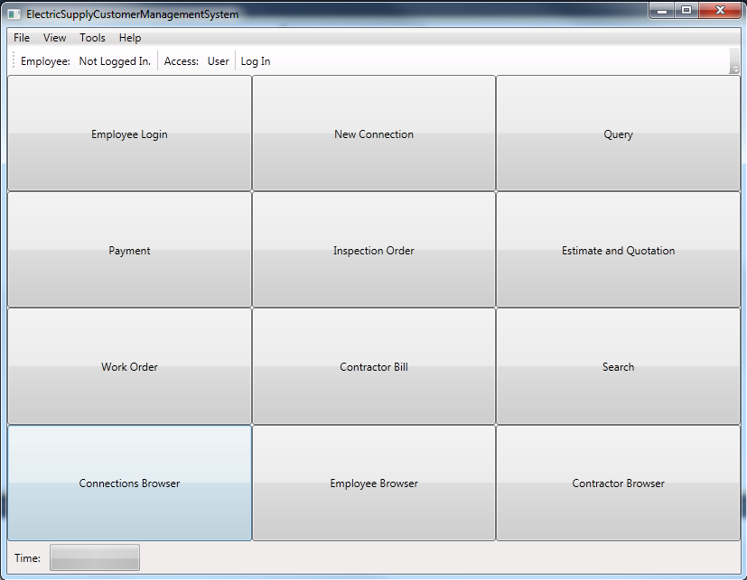

Security measures:
- Every user need to login before using the software. So its access protected.
- User information is maintained in a highly secure manner. So that unauthorized use can be prohibited.

limitations of the project:
- We are not using any centralized server
- Multiple backup of data are getting created , so some of the space is redundant.

Any Client/Industry:

E-Komfort Zone
Bamangachi Station Road,
P.O: Bamangachi, P.S: Barasat,
Dist: North 24 Pgs
West Bengal- 743706

Future Scope and Further enhancement of the project:
    - Currently this software is aimed for a single electric supply office customer management. It can be extended to support networked multiple electric supply office and have a centralized database and to serve wider range of customers of Electric Supply around the country.
    - To support UNIX / Linux, MAC OSX Operating systems.
    - Integration with Electric Billing System.

Bibliography:
- http://www.google.co.in
- http://en.wikipedia.org
- http://msdn.microsoft.com/en-us/
- http://www.microsoft.com/en-us/default.aspx
- http://www.codeplex.com/
- http://stackoverflow.com/
- http://www.codeguru.com/
- http://www.w3schools.com

----------------------------- Thank You-------------------------

